**CSS INTRODUCTION**

* CSS stands for Cascading Style Sheets
* CSS is the language we use to style an HTML document.
* CSS describes how HTML elements should be displayed.
* CSS was first proposed by [Håkon Wium Lie](https://en.wikipedia.org/wiki/H%C3%A5kon_Wium_Lie" \o ") on 10 October 1994. At the time, Lie was working with [Tim Berners-Lee](https://en.wikipedia.org/wiki/Tim_Berners-Lee) (English computer scientist and inventor of world wide web)  at [CERN](https://en.wikipedia.org/wiki/CERN) (Uropion organization of nuclear research)
* **(CSS1)**: being released in 1996. proposal by [Bert Bos](https://en.wikipedia.org/wiki/Bert_Bos) he became co-author of CSS1, and is regarded as co-creator of CSS.
* <font>, and color attributes were added to the HTML 3.2 specification
* where fonts and color information were added to every single page, became a long and expensive process.
* CSS removed the style formatting from the HTML page!
* **CSS2 :** CSS level 2 specification was developed by the W3C and published as a recommendation in May 1998
* A superset of CSS 1, CSS 2 includes a number of new capabilities like absolute, relative, and fixed positioning of elements and [z-index](https://en.wikipedia.org/wiki/Z-index)
* "CSS 2.1", fixes errors in CSS 2,
* The earliest CSS 3 drafts were published in June 1999.

## CSS Type:

* Inline CSS.

**Inline CSS:** Inline CSS contains the [CSS](https://www.geeksforgeeks.org/css/) property in the body section attached to the element is known as inline CSS. This kind of style is specified within an HTML tag using the style attribute.

* Internal/ Embedded CSS.

within the <style> tag inside the head section of the [HTML](https://www.geeksforgeeks.org/html/) file.

* External CSS.

External CSS contains separate [CSS](https://www.geeksforgeeks.org/css/) files that contain only style properties with the help of tag attributes (For example class, id, heading, … etc). [CSS](https://www.geeksforgeeks.org/css/) property is written in a separate file with a .css extension and should be linked to the [HTML](https://www.geeksforgeeks.org/html/) document using a **link** tag.

## CSS Syntax

* A CSS rule consists of a selector and a declaration block

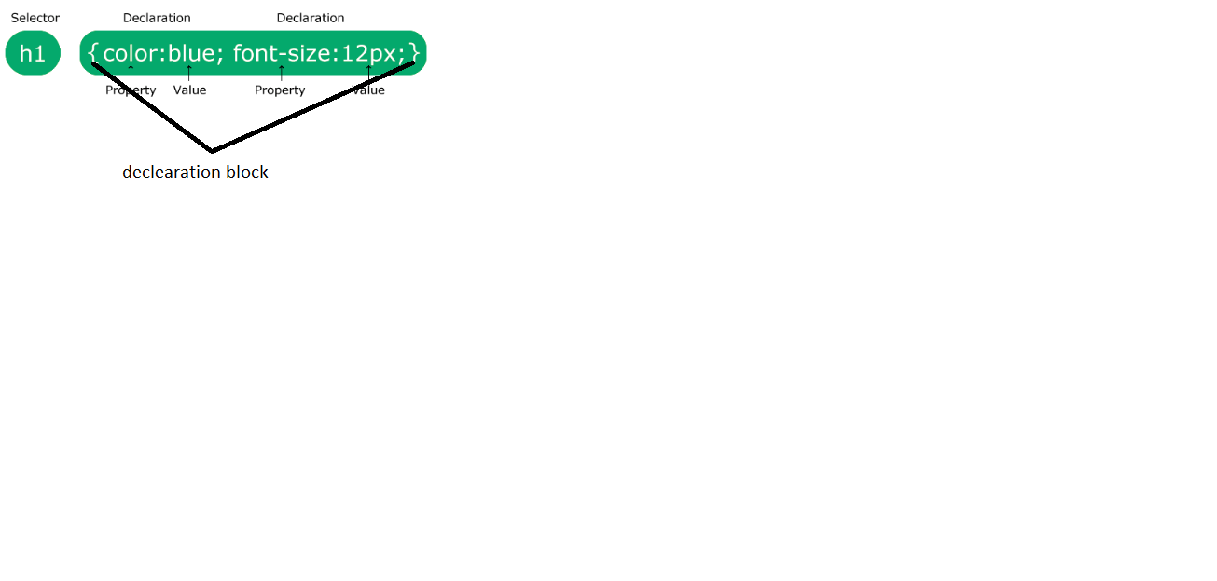

* The selector points to the HTML element you want to style.
* The declaration block contains one or more declarations separated by semicolons.
* Each declaration includes a CSS property name and a value, separated by a colon.
* Multiple CSS declarations are separated with semicolons, and declaration blocks are surrounded by curly braces.

### **Example**

p {  
  color: red;

}

* p is a selector in CSS (it points to the HTML element you want to style: <p>).
* color is a property, and red is the property value

----------------------------------------------------------------------------------